Github https://github.com/k256534/PF-labs

ABRAR UL HASSAN 25K 6534
QUESTION 1
#include<stdio.h>
#include<string.h>
#include<ctype.h>
int main() {
char name[50];
int valid = 1;
printf("Enter student name: ");
fgets(name, sizeof(name), stdin);
name[strcspn(name, "\n")] = '\0';
int len = strlen(name);
if(len < 3 || len > 20)
valid = 0;
if(name[0] == ' ' || name[len - 1] == ' ')
valid = 0;
for(int i = 0; i < len; i++){
if(isdigit(name[i])){
valid = 0;
break;
}
}
if(valid)
printf("Valid Name\n");
else
printf("Invalid Name\n");

printf("Length: %d\n", len);

return 0;
}

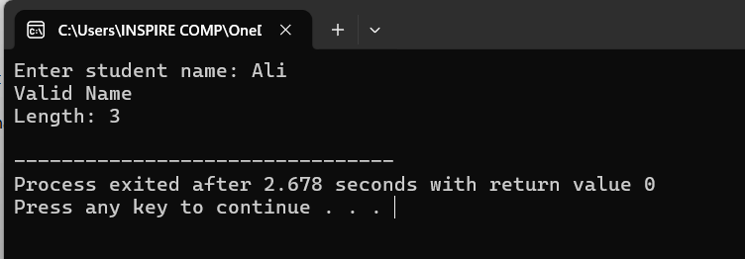

QUESTION 2
#include<stdio.h>
#include<string.h>
int main() {
char password[] = "fast123";
char input[50];
int attempts = 0;
while(attempts < 3){
printf("Enter password: ");
scanf("%s", input);
if(strlen(input) == 0){
printf("Empty password not allowed\n");
continue;
}

int cmp = strcmp(input, password);

if(cmp == 0){
printf("Access Granted\n");
return 0;
}
else{
if(cmp < 0)
printf("Input is alphabetically BEFORE stored password\n");
else
printf("Input is alphabetically AFTER stored password\n");
}

attempts++;
if(attempts == 2){
if(strncmp(input, password, 3) == 0)
printf("Hint: First 3 characters match\n");
else
printf("Hint: First 3 characters do not match\n");
}
}
printf("Account Locked after 3 failed attempts\n");

return 0;
}
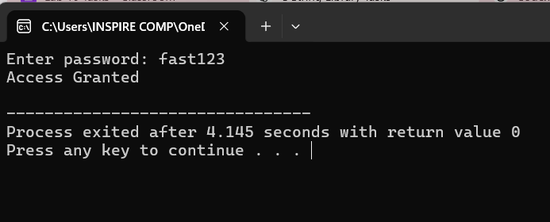
QUESTION 3
#include<stdio.h>
#include<string.h>
int main() {
char email[100];
char copy[100];
char formatted[150] = "Email: ";
printf("Enter email: ");
scanf("%s", email);
strcpy(copy, email);
char *ptr = strchr(copy, '@');

if(ptr == NULL){
printf("Invalid email (no @ found)\n");
return 0;
}
char *domain = ptr + 1;
if(strstr(domain, ".") == NULL){
printf("Invalid domain (no . found)\n");
return 0;
}
printf("Domain: %s\n", domain);
strcat(formatted, copy);

printf("%s\n", formatted);

return 0;
}
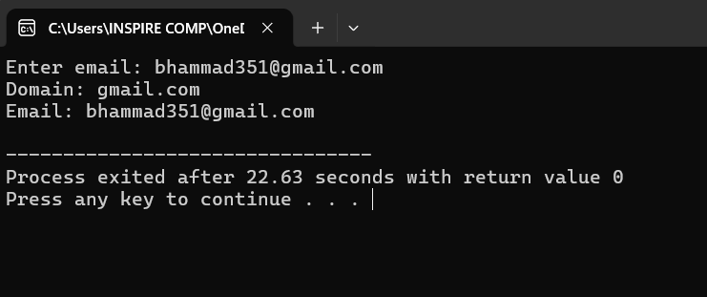
QUESTION 4
#include<stdio.h>
#include<string.h>
int main() {
char names[5][30];
char search[30];
for(int i = 0; i < 5; i++){
printf("Enter name %d: ", i+1);
fgets(names[i], 30, stdin);
names[i][strcspn(names[i], "\n")] = '\0';
}
printf("\nStudent List:\n");
for(int i = 0; i < 5; i++){
printf("%s\n", names[i]);
}

printf("\nEnter name to search: ");
fgets(search, 30, stdin);
search[strcspn(search, "\n")] = '\0';

int found = 0;

for(int i = 0; i < 5; i++){
if(strcmp(names[i], search) == 0){
printf("Found at position %d\n", i);
found = 1;
break;
}
}
if(!found){
printf("Student not found\n");
}
return 0;
}
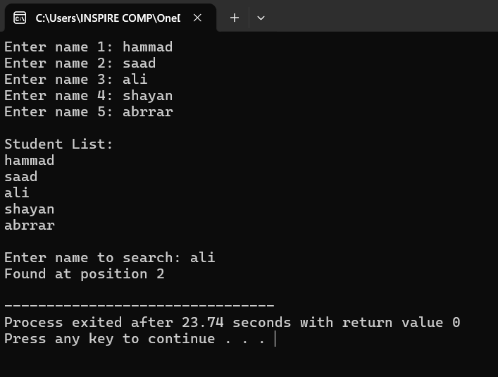
QUESTION 5
#include<stdio.h>
#include<string.h>
int main() {
char words[6][20];
int seen[6] = {0};
for(int i = 0; i < 6; i++){
printf("Enter word %d: ", i+1);
scanf("%s", words[i]);
}
for(int i = 0; i < 6; i++){

if(seen[i] == 1)
continue;

int count = 1;

for(int j = i + 1; j < 6; j++){
if(strcmp(words[i], words[j]) == 0){
count++;
seen[j] = 1;
}
}
printf("\nWord: %s\n", words[i]);
printf("Frequency: %d\n", count);
printf("Characters: ");
for(int k = 0; words[i][k] != '\0'; k++){
printf("%c ", words[i][k]);
}
printf("\n");
}
return 0;
}
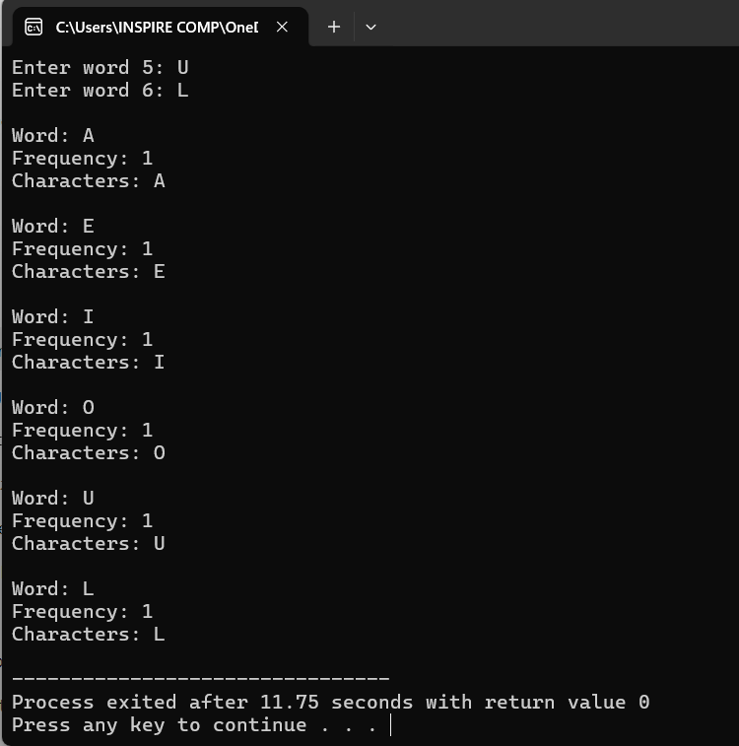
QUESTION 6
#include<stdio.h>
int main() {
FILE *fptr;
char name[30];
int grade;
fptr = fopen("grades.txt", "w");

if(fptr == NULL){
printf("Error opening file\n");
return 1;
}
for(int i = 0; i < 3; i++){
printf("Enter name and grade: ");
scanf("%s %d", name, &grade);
fprintf(fptr, "%s %d\n", name, grade);
}
fclose(fptr);

fptr = fopen("grades.txt", "r");

if(fptr == NULL){
printf("Error opening file\n");
return 1;
}
while(fscanf(fptr, "%s %d", name, &grade) != EOF){
printf("%s %d\n", name, grade);
}
fclose(fptr);
return 0;
}
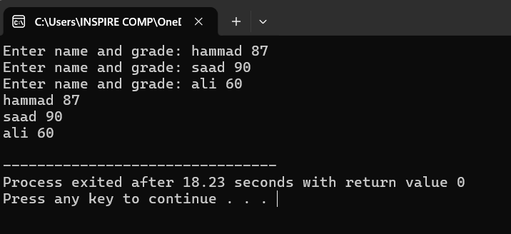
QUESTION 7
#include<stdio.h>
int main() {
FILE *fptr;
char product[30];
int qty;
fptr = fopen("inventory.txt", "a");
if(fptr == NULL){
printf("Error opening file\n");
return 1;
}
printf("Enter product and quantity: ");
scanf("%s %d", product, &qty);
fprintf(fptr, "%s %d\n", product, qty);

fclose(fptr);

fptr = fopen("inventory.txt", "r");

if(fptr == NULL){
printf("Error opening file\n");
return 1;
}
while(fscanf(fptr, "%s %d", product, &qty) != EOF){
printf("%s %d\n", product, qty);
}
fclose(fptr);
return 0;
}
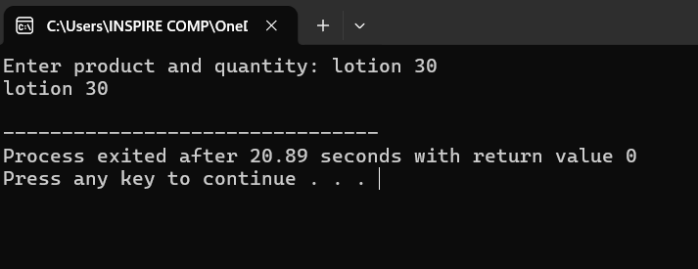
QUESTION 8
#include<stdio.h>
int main() {
FILE *fptr;
int score, sum = 0, val, count = 0;
float avg;

fptr = fopen("survey.txt", "w");

if(fptr == NULL){
printf("Error opening file\n");
return 1;
}
for(int i = 0; i < 5; i++){
printf("Enter score: ");
scanf("%d", &score);
fprintf(fptr, "%d\n", score);
}
fclose(fptr);

fptr = fopen("survey.txt", "r");
if(fptr == NULL){
printf("Error opening file\n");
return 1;
}
while(fscanf(fptr, "%d", &val) != EOF){
sum += val;
count++;
}
fclose(fptr);
avg = (float)sum / count;
printf("Sum = %d\n", sum);
printf("Average = %.2f\n", avg);
return 0;
}
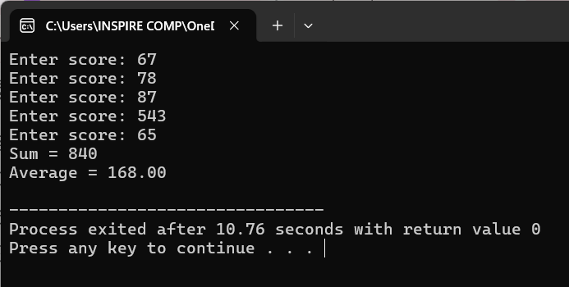
QUESTION 9
#include<stdio.h>
int main() {
FILE *fptr;

fptr = fopen("config.txt", "r");

if(fptr == NULL){
printf("File not found. Creating default config...\n");

fptr = fopen("config.txt", "w");

if(fptr == NULL){
printf("Error creating file\n");
return 1;
}

fprintf(fptr, "max_users=50\n");
fprintf(fptr, "timeout=30\n");
fprintf(fptr, "mode=auto\n");

fclose(fptr);

printf("Default config created\n");
}
else{
printf("Config file found\n");
fclose(fptr);
}

return 0;
}
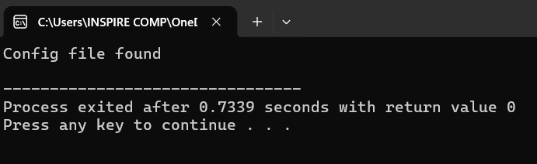
QUESTION 10
#include<stdio.h>
int main() {
FILE *fptr;
char name[30];
int s1, s2, s3;
float avg;
char status[10];
char line[100];

printf("Enter name: ");
scanf("%s", name);

printf("Enter 3 scores: ");
scanf("%d %d %d", &s1, &s2, &s3);

avg = (s1 + s2 + s3) / 3.0;
if(avg >= 50)
sprintf(status, "Pass");
else
sprintf(status, "Fail");

fptr = fopen("report.txt", "w+");

if(fptr == NULL){
printf("Error opening file\n");
return 1;
}
fprintf(fptr, "Name: %s\n", name);
fprintf(fptr, "Scores: %d %d %d\n", s1, s2, s3);
fprintf(fptr, "Average: %.2f\n", avg);
fprintf(fptr, "Status: %s\n", status);

rewind(fptr);
while(fgets(line, sizeof(line), fptr) != NULL){
printf("%s", line);
}
fclose(fptr);
return 0;
}
